NAME – ADITYA SINGH
ROLLNO-25/SCA/BCAC/001

PROGRAM NO-1
#include <stdio.h>

#define MAX 100

int main() {
int arr[MAX], n = 0;
int choice, pos, value, i;

while(1) {
printf("\n----- ARRAY OPERATIONS -----\n");
printf("1. Insert\n");
printf("2. Delete\n");
printf("3. Display\n");
printf("4. Exit\n");
printf("Enter your choice: ");
scanf("%d", &choice);

switch(choice) {

case 1: // Insertion
if(n >= MAX) {
printf("Array is full! Cannot insert.\n");
break;
}

printf("Enter position (1 to %d): ", n + 1);
scanf("%d", &pos);

if(pos < 1 || pos > n + 1) {
printf("Invalid position!\n");
break;
}

printf("Enter value to insert: ");
scanf("%d", &value);

for(i = n; i >= pos; i--) {
arr[i] = arr[i - 1];
}

arr[pos - 1] = value;
n++;

printf("Element inserted successfully.\n");
break;

case 2: // Deletion
if(n == 0) {
printf("Array is empty! Cannot delete.\n");
break;
}

printf("Enter position (1 to %d): ", n);
scanf("%d", &pos);

if(pos < 1 || pos > n) {
printf("Invalid position!\n");
break;
}

for(i = pos - 1; i < n - 1; i++) {
arr[i] = arr[i + 1];
}

n--;
printf("Element deleted successfully.\n");
break;

case 3: // Display
if(n == 0) {
printf("Array is empty!\n");
} else {
printf("Array elements are:\n");
for(i = 0; i < n; i++) {
printf("%d ", arr[i]);
}
printf("\n");
}
break;

case 4: // Exit
printf("Exiting program...\n");
return 0;

default:
printf("Invalid choice! Try again.\n");
}
}

return 0;
}
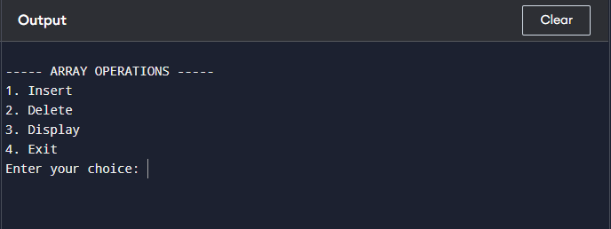

PROGRAM NO-2
#include <stdio.h>

int main() {
int A[10][10], B[10][10], C[10][10], T[10][10];
int r1, c1, r2, c2;
int i, j, k, choice;

printf("Enter rows and columns of Matrix A: ");
scanf("%d%d", &r1, &c1);

printf("Enter rows and columns of Matrix B: ");
scanf("%d%d", &r2, &c2);

printf("Enter elements of Matrix A:\n");
for(i = 0; i < r1; i++) {
for(j = 0; j < c1; j++) {
scanf("%d", &A[i][j]);
}
}

printf("Enter elements of Matrix B:\n");
for(i = 0; i < r2; i++) {
for(j = 0; j < c2; j++) {
scanf("%d", &B[i][j]);
}
}

printf("\n1. Sum\n2. Subtraction\n3. Product\n4. Transpose of Matrix A\n");
printf("Enter your choice: ");
scanf("%d", &choice);

switch(choice) {

case 1: // Sum
if(r1 == r2 && c1 == c2) {
for(i = 0; i < r1; i++) {
for(j = 0; j < c1; j++) {
C[i][j] = A[i][j] + B[i][j];
printf("%d ", C[i][j]);
}
printf("\n");
}
} else {
printf("Addition not possible!\n");
}
break;

case 2: // Subtraction
if(r1 == r2 && c1 == c2) {
for(i = 0; i < r1; i++) {
for(j = 0; j < c1; j++) {
C[i][j] = A[i][j] - B[i][j];
printf("%d ", C[i][j]);
}
printf("\n");
}
} else {
printf("Subtraction not possible!\n");
}
break;

case 3: // Product
if(c1 == r2) {
for(i = 0; i < r1; i++) {
for(j = 0; j < c2; j++) {
C[i][j] = 0;
for(k = 0; k < c1; k++) {
C[i][j] += A[i][k] * B[k][j];
}
printf("%d ", C[i][j]);
}
printf("\n");
}
} else {
printf("Multiplication not possible!\n");
}
break;

case 4: // Transpose of A
for(i = 0; i < r1; i++) {
for(j = 0; j < c1; j++) {
T[j][i] = A[i][j];
}
}

printf("Transpose of Matrix A:\n");
for(i = 0; i < c1; i++) {
for(j = 0; j < r1; j++) {
printf("%d ", T[i][j]);
}
printf("\n");
}
break;

default:
printf("Invalid choice!\n");
}

return 0;
}
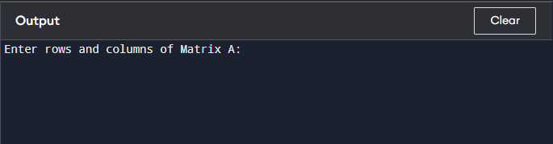

PROGRAM NO-3
#include <stdio.h>

#define MAX 100

/* ---------- Utility Function ---------- */
void display(int arr[], int n) {
for(int i = 0; i < n; i++)
printf("%d ", arr[i]);
printf("\n");
}

/* ---------- Bubble Sort ---------- */
void bubbleSort(int arr[], int n) {
for(int i = 0; i < n - 1; i++) {
for(int j = 0; j < n - i - 1; j++) {
if(arr[j] > arr[j + 1]) {
int temp = arr[j];
arr[j] = arr[j + 1];
arr[j + 1] = temp;
}
}
}
}

/* ---------- Insertion Sort ---------- */
void insertionSort(int arr[], int n) {
for(int i = 1; i < n; i++) {
int key = arr[i];
int j = i - 1;

while(j >= 0 && arr[j] > key) {
arr[j + 1] = arr[j];
j--;
}
arr[j + 1] = key;
}
}

/* ---------- Quick Sort ---------- */
int partition(int arr[], int low, int high) {
int pivot = arr[high];
int i = low - 1;

for(int j = low; j < high; j++) {
if(arr[j] < pivot) {
i++;
int temp = arr[i];
arr[i] = arr[j];
arr[j] = temp;
}
}

int temp = arr[i + 1];
arr[i + 1] = arr[high];
arr[high] = temp;

return i + 1;
}

void quickSort(int arr[], int low, int high) {
if(low < high) {
int pi = partition(arr, low, high);
quickSort(arr, low, pi - 1);
quickSort(arr, pi + 1, high);
}
}

/* ---------- Merge Sort ---------- */
void merge(int arr[], int l, int m, int r) {
int n1 = m - l + 1;
int n2 = r - m;

int L[50], R[50];

for(int i = 0; i < n1; i++)
L[i] = arr[l + i];
for(int j = 0; j < n2; j++)
R[j] = arr[m + 1 + j];

int i = 0, j = 0, k = l;

while(i < n1 && j < n2) {
if(L[i] <= R[j])
arr[k++] = L[i++];
else
arr[k++] = R[j++];
}

while(i < n1)
arr[k++] = L[i++];

while(j < n2)
arr[k++] = R[j++];
}

void mergeSort(int arr[], int l, int r) {
if(l < r) {
int m = (l + r) / 2;
mergeSort(arr, l, m);
mergeSort(arr, m + 1, r);
merge(arr, l, m, r);
}
}

/* ---------- Heap Sort ---------- */
void heapify(int arr[], int n, int i) {
int largest = i;
int left = 2*i + 1;
int right = 2*i + 2;

if(left < n && arr[left] > arr[largest])
largest = left;

if(right < n && arr[right] > arr[largest])
largest = right;

if(largest != i) {
int temp = arr[i];
arr[i] = arr[largest];
arr[largest] = temp;

heapify(arr, n, largest);
}
}

void heapSort(int arr[], int n) {
for(int i = n/2 - 1; i >= 0; i--)
heapify(arr, n, i);

for(int i = n - 1; i > 0; i--) {
int temp = arr[0];
arr[0] = arr[i];
arr[i] = temp;

heapify(arr, i, 0);
}
}

/* ---------- Main Function ---------- */
int main() {
int arr[MAX], n, choice;

printf("Enter number of elements: ");
scanf("%d", &n);

printf("Enter elements:\n");
for(int i = 0; i < n; i++)
scanf("%d", &arr[i]);

printf("\n1. Bubble Sort\n2. Insertion Sort\n3. Quick Sort\n4. Merge Sort\n5. Heap Sort\n");
printf("Enter your choice: ");
scanf("%d", &choice);

switch(choice) {
case 1:
bubbleSort(arr, n);
break;
case 2:
insertionSort(arr, n);
break;
case 3:
quickSort(arr, 0, n - 1);
break;
case 4:
mergeSort(arr, 0, n - 1);
break;
case 5:
heapSort(arr, n);
break;
default:
printf("Invalid choice!\n");
return 0;
}

printf("Sorted array:\n");
display(arr, n);

return 0;
}
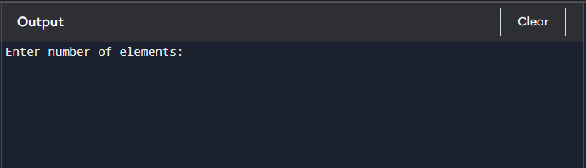

PROGRAM NO-4
#include <stdio.h>

/* -------- Linear Search -------- */
int linearSearch(int arr[], int n, int key) {
for(int i = 0; i < n; i++) {
if(arr[i] == key)
return i; // return index if found
}
return -1; // not found
}

/* -------- Binary Search -------- */
/* Array must be sorted */
int binarySearch(int arr[], int n, int key) {
int low = 0, high = n - 1, mid;

while(low <= high) {
mid = (low + high) / 2;

if(arr[mid] == key)
return mid;
else if(arr[mid] < key)
low = mid + 1;
else
high = mid - 1;
}
return -1; // not found
}

/* -------- Main Function -------- */
int main() {
int arr[100], n, key, choice, result;

printf("Enter number of elements: ");
scanf("%d", &n);

printf("Enter elements:\n");
for(int i = 0; i < n; i++) {
scanf("%d", &arr[i]);
}

printf("Enter element to search: ");
scanf("%d", &key);

printf("\n1. Linear Search\n2. Binary Search (Array must be sorted)\n");
printf("Enter your choice: ");
scanf("%d", &choice);

switch(choice) {
case 1:
result = linearSearch(arr, n, key);
break;

case 2:
result = binarySearch(arr, n, key);
break;

default:
printf("Invalid choice!\n");
return 0;
}

if(result != -1)
printf("Element found at position %d\n", result + 1);
else
printf("Element not found.\n");

return 0;
}
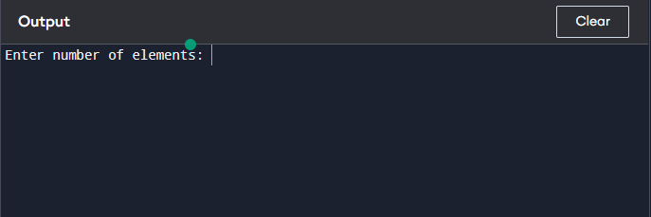

PROGRAM NO-5
#include <stdio.h>
#define MAX 5

/* ---------- STACK ---------- */
int stack[MAX], top = -1;

void push(int value) {
if(top == MAX - 1)
printf("Stack Overflow!\n");
else {
stack[++top] = value;
printf("Pushed %d into stack.\n", value);
}
}

void pop() {
if(top == -1)
printf("Stack Underflow!\n");
else
printf("Popped %d from stack.\n", stack[top--]);
}

void displayStack() {
if(top == -1)
printf("Stack is empty.\n");
else {
printf("Stack elements:\n");
for(int i = top; i >= 0; i--)
printf("%d\n", stack[i]);
}
}

/* ---------- LINEAR QUEUE ---------- */
int queue[MAX], front = -1, rear = -1;

void enqueue(int value) {
if(rear == MAX - 1)
printf("Queue Overflow!\n");
else {
if(front == -1)
front = 0;
queue[++rear] = value;
printf("Inserted %d into queue.\n", value);
}
}

void dequeue() {
if(front == -1 || front > rear)
printf("Queue Underflow!\n");
else
printf("Deleted %d from queue.\n", queue[front++]);
}

void displayQueue() {
if(front == -1 || front > rear)
printf("Queue is empty.\n");
else {
printf("Queue elements:\n");
for(int i = front; i <= rear; i++)
printf("%d ", queue[i]);
printf("\n");
}
}

/* ---------- CIRCULAR QUEUE ---------- */
int cqueue[MAX], cfront = -1, crear = -1;

void cenqueue(int value) {
if((cfront == 0 && crear == MAX - 1) || (crear + 1) % MAX == cfront)
printf("Circular Queue Overflow!\n");
else {
if(cfront == -1)
cfront = 0;
crear = (crear + 1) % MAX;
cqueue[crear] = value;
printf("Inserted %d into circular queue.\n", value);
}
}

void cdequeue() {
if(cfront == -1)
printf("Circular Queue Underflow!\n");
else {
printf("Deleted %d from circular queue.\n", cqueue[cfront]);
if(cfront == crear)
cfront = crear = -1;
else
cfront = (cfront + 1) % MAX;
}
}

void displayCQueue() {
if(cfront == -1)
printf("Circular Queue is empty.\n");
else {
printf("Circular Queue elements:\n");
int i = cfront;
while(1) {
printf("%d ", cqueue[i]);
if(i == crear)
break;
i = (i + 1) % MAX;
}
printf("\n");
}
}

/* ---------- MAIN MENU ---------- */
int main() {
int choice, value;

while(1) {
printf("\n1.Push (Stack)\n2.Pop (Stack)\n3.Display Stack\n");
printf("4.Enqueue (Queue)\n5.Dequeue (Queue)\n6.Display Queue\n");
printf("7.Enqueue (Circular Queue)\n8.Dequeue (Circular Queue)\n9.Display Circular Queue\n");
printf("10.Exit\nEnter choice: ");
scanf("%d", &choice);

switch(choice) {
case 1:
printf("Enter value: ");
scanf("%d", &value);
push(value);
break;
case 2:
pop();
break;
case 3:
displayStack();
break;
case 4:
printf("Enter value: ");
scanf("%d", &value);
enqueue(value);
break;
case 5:
dequeue();
break;
case 6:
displayQueue();
break;
case 7:
printf("Enter value: ");
scanf("%d", &value);
cenqueue(value);
break;
case 8:
cdequeue();
break;
case 9:
displayCQueue();
break;
case 10:
return 0;
default:
printf("Invalid choice!\n");
}
}

return 0;
}
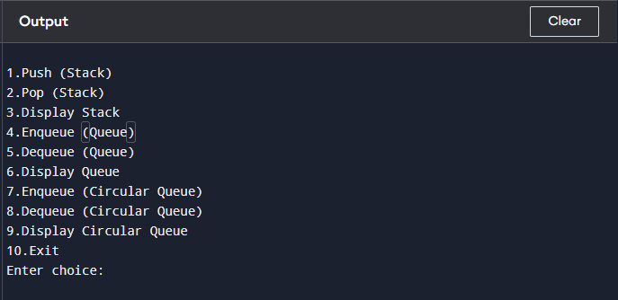

PROGRAM NO-6
#include <stdio.h>
#include <ctype.h>

#define MAX 50

int stack[MAX];
int top = -1;

/* Push element onto stack */
void push(int x)
{
stack[++top] = x;
}

/* Pop element from stack */
int pop()
{
return stack[top--];
}

int main()
{
char postfix[MAX];
int i, op1, op2, result;

printf("Enter postfix expression: ");
scanf("%s", postfix);

for (i = 0; postfix[i] != '\0'; i++)
{
/* If operand, push to stack */
if (isdigit(postfix[i]))
{
push(postfix[i] - '0');
}
else
{
/* Operator encountered */
op2 = pop();
op1 = pop();

switch (postfix[i])
{
case '+':
result = op1 + op2;
break;
case '-':
result = op1 - op2;
break;
case '*':
result = op1 * op2;
break;
case '/':
result = op1 / op2;
break;
default:
printf("Invalid operator\n");
return 0;
}
push(result);
}
}

printf("Result = %d\n", pop());
return 0;
}
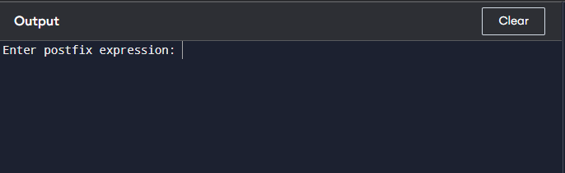

PROGRAM NO-7
#include <stdio.h>
#include <ctype.h>
#include <string.h>

#define MAX 100

char stack[MAX];
int top = -1;

/* Push function */
void push(char x)
{
stack[++top] = x;
}

/* Pop function */
char pop()
{
return stack[top--];
}

/* Check precedence */
int precedence(char op)
{
if (op == '^')
return 3;
else if (op == '*' || op == '/')
return 2;
else if (op == '+' || op == '-')
return 1;
else
return 0;
}

int main()
{
char infix[MAX], postfix[MAX];
int i, j = 0;

printf("Enter Infix Expression: ");
scanf("%s", infix);

for (i = 0; infix[i] != '\0'; i++)
{
/* If operand, add to postfix */
if (isalnum(infix[i]))
{
postfix[j++] = infix[i];
}
/* If '(', push to stack */
else if (infix[i] == '(')
{
push(infix[i]);
}
/* If ')', pop until '(' */
else if (infix[i] == ')')
{
while (stack[top] != '(')
{
postfix[j++] = pop();
}
pop(); // remove '('
}
/* If operator */
else
{
while (top != -1 &&
precedence(stack[top]) >= precedence(infix[i]))
{
postfix[j++] = pop();
}
push(infix[i]);
}
}

/* Pop remaining operators */
while (top != -1)
{
postfix[j++] = pop();
}

postfix[j] = '\0';

printf("Postfix Expression: %s\n", postfix);

return 0;
}
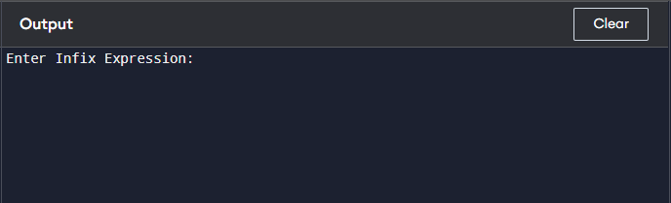

PROGRAM NO-8
#include <stdio.h>
#include <stdlib.h>

struct Node {
int data;
struct Node* next;
};

struct Node* head = NULL;

// Insert at beginning
void insert(int val) {
struct Node* newNode = (struct Node*)malloc(sizeof(struct Node));
newNode->data = val;
newNode->next = head;
head = newNode;
}

// Delete from beginning
void delete() {
if (head == NULL) {
printf("List is empty\n");
return;
}
struct Node* temp = head;
head = head->next;
free(temp);
}

// Display
void display() {
struct Node* temp = head;
while (temp != NULL) {
printf("%d -> ", temp->data);
temp = temp->next;
}
printf("NULL\n");
}

int main() {
insert(10);
insert(20);
insert(30);
display();
delete();
display();
return 0;
}
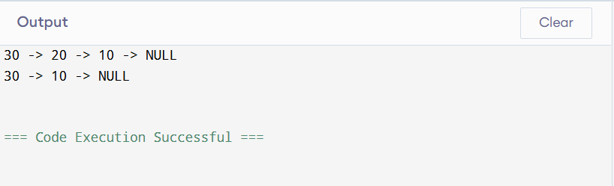
PROGRAM NO-9
#include <stdio.h>
#include <stdlib.h>

struct Node {
int data;
struct Node* next;
};

struct Node* last = NULL;

void insert(int val) {
struct Node* newNode = (struct Node*)malloc(sizeof(struct Node));
newNode->data = val;

if (last == NULL) {
last = newNode;
last->next = last;
} else {
newNode->next = last->next;
last->next = newNode;
last = newNode;
}
}

void delete() {
if (last == NULL) return;

struct Node* temp = last->next;

if (last == temp) {
last = NULL;
} else {
last->next = temp->next;
}
free(temp);
}

void display() {
if (last == NULL) return;

struct Node* temp = last->next;
do {
printf("%d -> ", temp->data);
temp = temp->next;
} while (temp != last->next);
printf("(circular)\n");
}

int main() {
insert(1);
insert(2);
insert(3);
display();
delete();
display();
return 0;
}
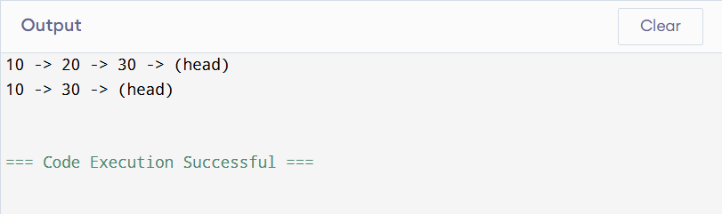
PROGRAM NO-10
#include <stdio.h>
#include <stdlib.h>

struct Node {
int data;
struct Node* next;
};

struct Node *top = NULL, *front = NULL, *rear = NULL;

/* Stack */
void push(int val) {
struct Node* temp = malloc(sizeof(struct Node));
temp->data = val;
temp->next = top;
top = temp;
}

void pop() {
if (top == NULL) return;
struct Node* temp = top;
top = top->next;
free(temp);
}

/* Queue */
void enqueue(int val) {
struct Node* temp = malloc(sizeof(struct Node));
temp->data = val;
temp->next = NULL;

if (rear == NULL)
front = rear = temp;
else {
rear->next = temp;
rear = temp;
}
}

void dequeue() {
if (front == NULL) return;
struct Node* temp = front;
front = front->next;
if (front == NULL) rear = NULL;
free(temp);
}
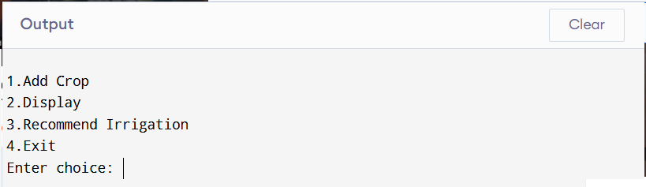

PROGRAM NO-11
#include <stdio.h>
#include <stdlib.h>

// Define node
struct Node {
int data;
struct Node* next;
};

// Function to create a new node
struct Node* createNode(int data) {
struct Node* newNode = (struct Node*)malloc(sizeof(struct Node));
newNode->data = data;
newNode->next = NULL;
return newNode;
}

// Function to concatenate two linked lists
struct Node* concatenate(struct Node* head1, struct Node* head2) {
// If first list is empty, return second
if (head1 == NULL) return head2;

// Traverse to the last node of first list
struct Node* temp = head1;
while (temp->next != NULL) {
temp = temp->next;
}

// Link last node of first list to head of second
temp->next = head2;

return head1;
}

// Function to print list
void printList(struct Node* head) {
struct Node* temp = head;
while (temp != NULL) {
printf("%d -> ", temp->data);
temp = temp->next;
}
printf("NULL\n");
}

int main() {
// First list: 1 -> 2 -> 3
struct Node* head1 = createNode(1);
head1->next = createNode(2);
head1->next->next = createNode(3);

// Second list: 4 -> 5 -> 6
struct Node* head2 = createNode(4);
head2->next = createNode(5);
head2->next->next = createNode(6);

// Concatenate lists
struct Node* result = concatenate(head1, head2);

// Print result
printList(result);

return 0;
}
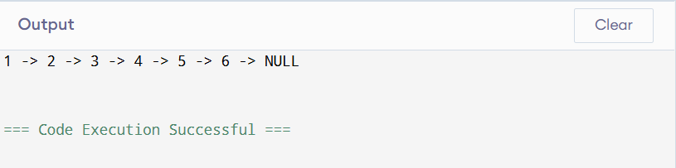

PROGRAM NO-12
#include <stdio.h>
#include <stdlib.h>

// Define structure
struct Node {
int data;
struct Node* prev;
struct Node* next;
};

// Create a new node
struct Node* createNode(int data) {
struct Node* newNode = (struct Node*)malloc(sizeof(struct Node));
newNode->data = data;
newNode->prev = NULL;
newNode->next = NULL;
return newNode;
}

// Insert at beginning
struct Node* insertAtBeginning(struct Node* head, int data) {
struct Node* newNode = createNode(data);
if (head != NULL) {
head->prev = newNode;
newNode->next = head;
}
return newNode;
}

// Insert at end
struct Node* insertAtEnd(struct Node* head, int data) {
struct Node* newNode = createNode(data);

if (head == NULL)
return newNode;

struct Node* temp = head;
while (temp->next != NULL)
temp = temp->next;

temp->next = newNode;
newNode->prev = temp;

return head;
}

// Delete from beginning
struct Node* deleteFromBeginning(struct Node* head) {
if (head == NULL) {
printf("List is empty\n");
return NULL;
}

struct Node* temp = head;
head = head->next;

if (head != NULL)
head->prev = NULL;

free(temp);
return head;
}

// Delete from end
struct Node* deleteFromEnd(struct Node* head) {
if (head == NULL) {
printf("List is empty\n");
return NULL;
}

struct Node* temp = head;

// Only one node
if (temp->next == NULL) {
free(temp);
return NULL;
}

while (temp->next != NULL)
temp = temp->next;

temp->prev->next = NULL;
free(temp);

return head;
}

// Display list forward
void displayForward(struct Node* head) {
struct Node* temp = head;
printf("Forward: ");
while (temp != NULL) {
printf("%d <-> ", temp->data);
temp = temp->next;
}
printf("NULL\n");
}

// Display list backward
void displayBackward(struct Node* head) {
struct Node* temp = head;

if (temp == NULL) return;

// Go to last node
while (temp->next != NULL)
temp = temp->next;

printf("Backward: ");
while (temp != NULL) {
printf("%d <-> ", temp->data);
temp = temp->prev;
}
printf("NULL\n");
}

// Main function
int main() {
struct Node* head = NULL;

// Insert elements
head = insertAtBeginning(head, 10);
head = insertAtBeginning(head, 5);
head = insertAtEnd(head, 20);
head = insertAtEnd(head, 30);

displayForward(head);
displayBackward(head);

// Delete elements
head = deleteFromBeginning(head);
head = deleteFromEnd(head);

displayForward(head);
displayBackward(head);

return 0;
}
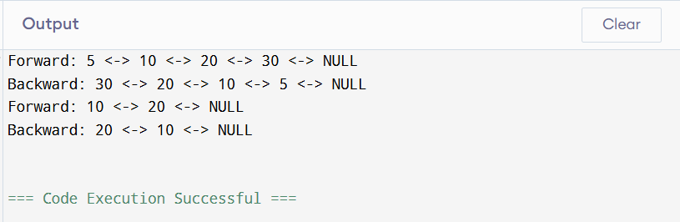

PROGRAM NO-13
#include <stdio.h>
#include <stdlib.h>

struct Node {
int data;
struct Node *left, *right;
};

struct Node* create(int val) {
struct Node* temp = malloc(sizeof(struct Node));
temp->data = val;
temp->left = temp->right = NULL;
return temp;
}

void inorder(struct Node* root) {
if (root != NULL) {
inorder(root->left);
printf("%d ", root->data);
inorder(root->right);
}
}

void preorder(struct Node* root) {
if (root != NULL) {
printf("%d ", root->data);
preorder(root->left);
preorder(root->right);
}
}

void postorder(struct Node* root) {
if (root != NULL) {
postorder(root->left);
postorder(root->right);
printf("%d ", root->data);
}
}

int main() {
struct Node* root = create(1);
root->left = create(2);
root->right = create(3);

printf("Inorder: ");
inorder(root);

printf("\nPreorder: ");
preorder(root);

printf("\nPostorder: ");
postorder(root);

return 0;
}
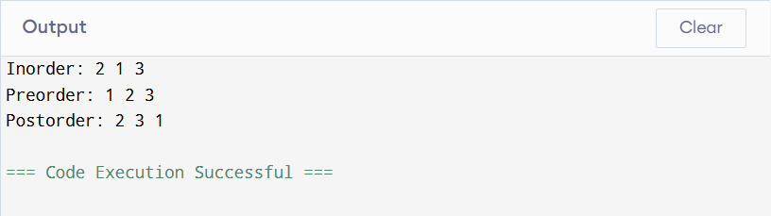

PROGRAM NO-14
#include <stdio.h>
#include <stdlib.h>

struct Node {
int data;
struct Node *left, *right;
};

// Create new node
struct Node* createNode(int value) {
struct Node* newNode = (struct Node*)malloc(sizeof(struct Node));
newNode->data = value;
newNode->left = newNode->right = NULL;
return newNode;
}

// Insert node
struct Node* insert(struct Node* root, int value) {
if (root == NULL)
return createNode(value);

if (value < root->data)
root->left = insert(root->left, value);
else if (value > root->data)
root->right = insert(root->right, value);

return root;
}

// Find minimum value node
struct Node* minValueNode(struct Node* node) {
struct Node* current = node;
while (current && current->left != NULL)
current = current->left;
return current;
}

// Delete node
struct Node* deleteNode(struct Node* root, int value) {
if (root == NULL) return root;

if (value < root->data)
root->left = deleteNode(root->left, value);
else if (value > root->data)
root->right = deleteNode(root->right, value);
else {
// Node with one or no child
if (root->left == NULL) {
struct Node* temp = root->right;
free(root);
return temp;
}
else if (root->right == NULL) {
struct Node* temp = root->left;
free(root);
return temp;
}

// Node with two children
struct Node* temp = minValueNode(root->right);
root->data = temp->data;
root->right = deleteNode(root->right, temp->data);
}
return root;
}

// Inorder traversal
void inorder(struct Node* root) {
if (root != NULL) {
inorder(root->left);
printf("%d ", root->data);
inorder(root->right);
}
}

// Main menu
int main() {
struct Node* root = NULL;
int choice, value;

while (1) {
printf("\n1.Insert\n2.Delete\n3.Display(Inorder)\n4.Exit\n");
printf("Enter choice: ");
scanf("%d", &choice);

switch (choice) {
case 1:
printf("Enter value: ");
scanf("%d", &value);
root = insert(root, value);
break;
case 2:
printf("Enter value to delete: ");
scanf("%d", &value);
root = deleteNode(root, value);
break;
case 3:
printf("BST (Inorder): ");
inorder(root);
printf("\n");
break;
case 4:
exit(0);
default:
printf("Invalid choice!\n");
}
}
}
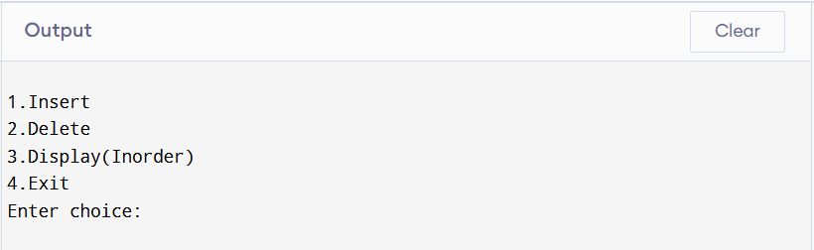

PROGRAM NO-15
#include <stdio.h>

#define MAX 10

int adj[MAX][MAX];
int n; // number of vertices

// Create graph
void createGraph() {
printf("Enter number of vertices: ");
scanf("%d", &n);

for (int i = 0; i < n; i++)
for (int j = 0; j < n; j++)
adj[i][j] = 0;
}

// Insert edge
void insertEdge() {
int u, v;
printf("Enter edge (u v): ");
scanf("%d %d", &u, &v);

if (u >= n || v >= n) {
printf("Invalid vertices!\n");
return;
}

adj[u][v] = 1;
adj[v][u] = 1; // undirected graph
}

// Print adjacency matrix
void printMatrix() {
printf("Adjacency Matrix:\n");
for (int i = 0; i < n; i++) {
for (int j = 0; j < n; j++)
printf("%d ", adj[i][j]);
printf("\n");
}
}

// List adjacent vertices
void adjacentVertices() {
int v;
printf("Enter vertex: ");
scanf("%d", &v);

if (v >= n) {
printf("Invalid vertex!\n");
return;
}

printf("Adjacent vertices of %d: ", v);
for (int i = 0; i < n; i++) {
if (adj[v][i] == 1)
printf("%d ", i);
}
printf("\n");
}

// Main menu
int main() {
int choice;

while (1) {
printf("\n1.Create Graph\n2.Insert Edge\n3.Print Matrix\n4.Adjacent Vertices\n5.Exit\n");
printf("Enter choice: ");
scanf("%d", &choice);

switch (choice) {
case 1:
createGraph();
break;
case 2:
insertEdge();
break;
case 3:
printMatrix();
break;
case 4:
adjacentVertices();
break;
case 5:
return 0;
default:
printf("Invalid choice!\n");
}
}
}
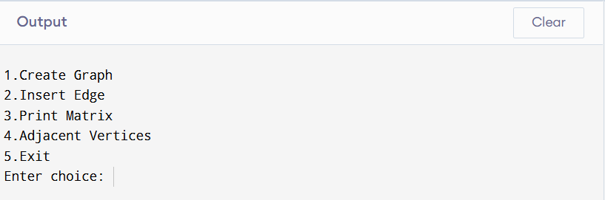

PROGRAM NO-16
#include <stdio.h>
#include <stdlib.h>
#include <string.h>

struct Month {
char eng[20];
char hindi[20];
struct Month* next;
};

// Create linked list of months
struct Month* createMonths() {
char *engMonths[] = {"January","February","March","April","May","June",
"July","August","September","October","November","December"};
char *hinMonths[] = {"Paush","Magh","Phalgun","Chaitra","Vaishakh","Jyeshtha",
"Ashadh","Shravan","Bhadrapad","Ashwin","Kartik","Margashirsha"};

struct Month *head = NULL, *temp, *newNode;

for (int i = 0; i < 12; i++) {
newNode = (struct Month*)malloc(sizeof(struct Month));
strcpy(newNode->eng, engMonths[i]);
strcpy(newNode->hindi, hinMonths[i]);
newNode->next = NULL;

if (head == NULL)
head = temp = newNode;
else {
temp->next = newNode;
temp = newNode;
}
}
return head;
}

// Convert function
void convert(struct Month* head, int m, int d, int y) {
struct Month* temp = head;
int count = 1;

while (temp != NULL && count < m) {
temp = temp->next;
count++;
}

if (temp != NULL) {
printf("\nGregorian Date: %d-%d-%d\n", d, m, y);
printf("Approx Hindi Date: %d %s %d\n", d, temp->hindi, y);
}
}

// Main
int main() {
struct Month* head = createMonths();
int d, m, y;

printf("Enter date (dd mm yyyy): ");
scanf("%d %d %d", &d, &m, &y);

convert(head, m, d, y);

return 0;
}
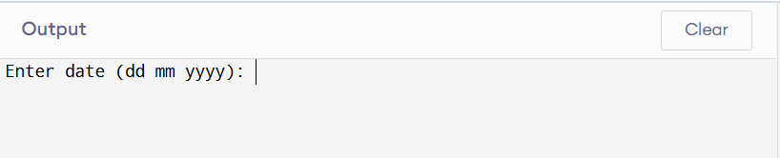

PROGRAM NO-17
#include <stdio.h>
#include <stdlib.h>
#include <string.h>

struct Crop {
char crop[20];
char soil[20];
int days;
struct Crop* next;
};

// Insert crop data
struct Crop* addCrop(struct Crop* head) {
struct Crop* newNode = (struct Crop*)malloc(sizeof(struct Crop));

printf("Enter crop name: ");
scanf("%s", newNode->crop);

printf("Enter soil type: ");
scanf("%s", newNode->soil);

printf("Enter irrigation interval (days): ");
scanf("%d", &newNode->days);

newNode->next = head;
return newNode;
}

// Display all crops
void display(struct Crop* head) {
struct Crop* temp = head;
printf("\nCrop Data:\n");
while (temp != NULL) {
printf("%s - %s - %d days\n", temp->crop, temp->soil, temp->days);
temp = temp->next;
}
}

// Recommendation
void recommend(struct Crop* head) {
char crop[20], soil[20];
struct Crop* temp = head;

printf("Enter crop: ");
scanf("%s", crop);

printf("Enter soil: ");
scanf("%s", soil);

while (temp != NULL) {
if (strcmp(temp->crop, crop) == 0 && strcmp(temp->soil, soil) == 0) {
printf("Irrigation needed every %d days\n", temp->days);
return;
}
temp = temp->next;
}

printf("No data found!\n");
}

// Main menu
int main() {
struct Crop* head = NULL;
int choice;

while (1) {
printf("\n1.Add Crop\n2.Display\n3.Recommend Irrigation\n4.Exit\n");
printf("Enter choice: ");
scanf("%d", &choice);

switch (choice) {
case 1:
head = addCrop(head);
break;
case 2:
display(head);
break;
case 3:
recommend(head);
break;
case 4:
exit(0);
default:
printf("Invalid choice!\n");
}
}
}
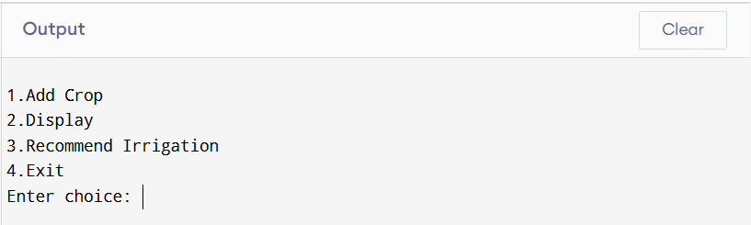

PROGRAM NO-18
#include <stdio.h>
#include <string.h>

#define MAX 5

char queue[MAX][50];
int front = -1, rear = -1;

void addPatient(char name[]) {
if ((rear + 1) % MAX == front) {
printf("Queue is Full!\n");
return;
}
if (front == -1) front = 0;
rear = (rear + 1) % MAX;
strcpy(queue[rear], name);
printf("Patient added.\n");
}

void servePatient() {
if (front == -1) {
printf("No patients.\n");
return;
}
printf("Serving: %s\n", queue[front]);

if (front == rear)
front = rear = -1;
else
front = (front + 1) % MAX;
}

void nextPatient() {
if (front == -1)
printf("No patients.\n");
else
printf("Next patient: %s\n", queue[front]);
}

void display() {
if (front == -1) {
printf("Queue empty.\n");
return;
}
int i = front;
printf("Waiting patients:\n");
while (1) {
printf("%s\n", queue[i]);
if (i == rear) break;
i = (i + 1) % MAX;
}
}

int main() {
int ch;
char name[50];

while (1) {
printf("\n1.Add 2.Next 3.Serve 4.Display 5.Exit\n");
scanf("%d", &ch);

switch (ch) {
case 1:
printf("Enter name: ");
scanf("%s", name);
addPatient(name);
break;
case 2:
nextPatient();
break;
case 3:
servePatient();
break;
case 4:
display();
break;
case 5:
return 0;
}
}
}
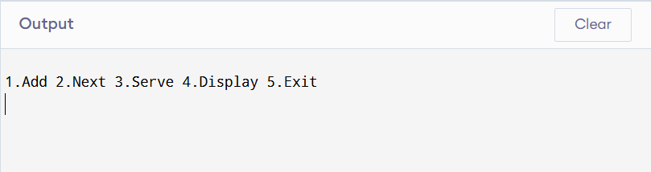

PROGRAM NO-19
#include <stdio.h>
#include <stdlib.h>
#include <string.h>

struct Node {
char name[50];
int value;
struct Node* next;
};

int numerology(char name[]) {
int sum = 0;
for (int i = 0; name[i]; i++) {
sum += (name[i] - 'A' + 1);
}
return sum;
}

void insert(struct Node** head, char name[]) {
struct Node* newNode = (struct Node*)malloc(sizeof(struct Node));
strcpy(newNode->name, name);
newNode->value = numerology(name);
newNode->next = *head;
*head = newNode;
}

void display(struct Node* head) {
while (head) {
printf("%s -> %d\n", head->name, head->value);
head = head->next;
}
}

int main() {
struct Node* head = NULL;
char name[50];
int n;

printf("Enter number of names: ");
scanf("%d", &n);

for (int i = 0; i < n; i++) {
printf("Enter name (CAPS): ");
scanf("%s", name);
insert(&head, name);
}

printf("\nNumerology Data:\n");
display(head);

return 0;
}
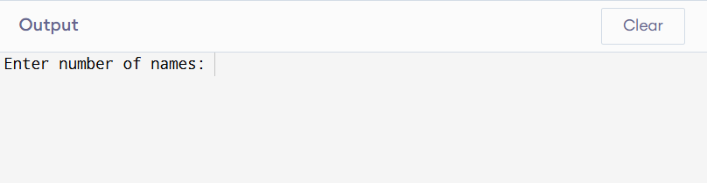

PROGRAM NO-20
#include <stdio.h>
#include <stdlib.h>
#include <string.h>

struct Node {
char species[50];
char habitat[50];
struct Node* next;
};

void add(struct Node** head, char sp[], char hb[]) {
struct Node* newNode = (struct Node*)malloc(sizeof(struct Node));
strcpy(newNode->species, sp);
strcpy(newNode->habitat, hb);
newNode->next = *head;
*head = newNode;
}

void display(struct Node* head) {
struct Node* temp;
char checked[50][50];
int count = 0;

while (head) {
int found = 0;
for (int i = 0; i < count; i++) {
if (strcmp(checked[i], head->habitat) == 0)
found = 1;
}

if (!found) {
strcpy(checked[count++], head->habitat);
printf("\nHabitat: %s\n", head->habitat);

temp = head;
while (temp) {
if (strcmp(temp->habitat, head->habitat) == 0)
printf(" - %s\n", temp->species);
temp = temp->next;
}
}
head = head->next;
}
}

int main() {
struct Node* head = NULL;
int n;
char sp[50], hb[50];

printf("Enter number of species: ");
scanf("%d", &n);

for (int i = 0; i < n; i++) {
printf("Species: ");
scanf("%s", sp);
printf("Habitat: ");
scanf("%s", hb);
add(&head, sp, hb);
}

display(head);

return 0;
}
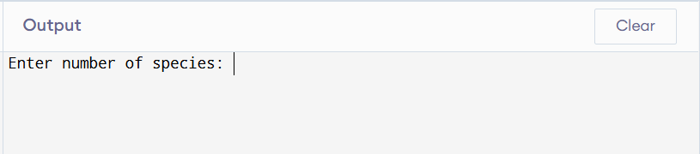

PROGRAM NO-21
#include <stdio.h>
#include <stdlib.h>

struct Node {
int steps, calories, sleep;
struct Node* next;
};

struct Node* last = NULL;

void add(int s, int c, int sl) {
struct Node* newNode = (struct Node*)malloc(sizeof(struct Node));
newNode->steps = s;
newNode->calories = c;
newNode->sleep = sl;

if (last == NULL) {
last = newNode;
last->next = last;
} else {
newNode->next = last->next;
last->next = newNode;
last = newNode;
}
}

void display() {
if (last == NULL) {
printf("No data.\n");
return;
}

struct Node* temp = last->next;
do {
printf("Steps:%d Calories:%d Sleep:%d hrs\n",
temp->steps, temp->calories, temp->sleep);
temp = temp->next;
} while (temp != last->next);
}

int main() {
int n, s, c, sl;

printf("Enter days: ");
scanf("%d", &n);

for (int i = 0; i < n; i++) {
printf("Steps Calories Sleep: ");
scanf("%d %d %d", &s, &c, &sl);
add(s, c, sl);
}

printf("\nHealth Data:\n");
display();

return 0;
}
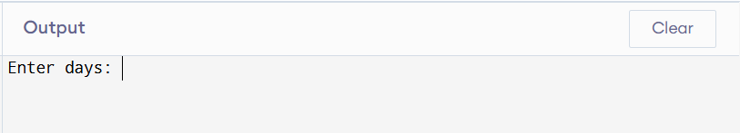

PROGRAM NO-22
#include <stdio.h>
#include <stdlib.h>
#include <string.h>

struct Node {
char text[100];
struct Node *next;
};

struct Node *head = NULL;

// Insert text
void insert(char data[]) {
struct Node *newNode = (struct Node*)malloc(sizeof(struct Node));
strcpy(newNode->text, data);

if (head == NULL) {
head = newNode;
newNode->next = head;
} else {
struct Node *temp = head;
while (temp->next != head) {
temp = temp->next;
}
temp->next = newNode;
newNode->next = head;
}
}

// Display texts
void display() {
if (head == NULL) {
printf("No texts available\n");
return;
}

struct Node *temp = head;
do {
printf("%s\n", temp->text);
temp = temp->next;
} while (temp != head);
}

int main() {
insert("Rigveda Verse 1");
insert("Yajurveda Ritual");
insert("Upanishad Philosophy");

printf("Vedic Texts:\n");
display();

return 0;
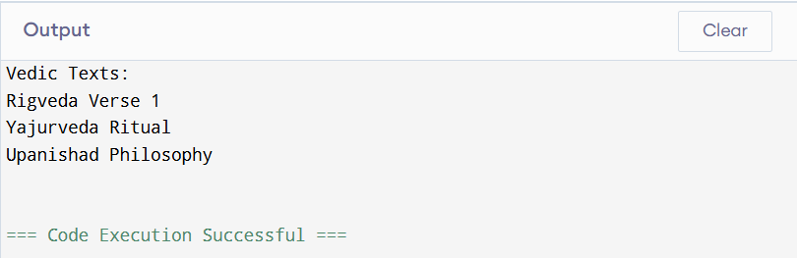

}PROGRAM NO-23
#include <stdio.h>
#include <stdlib.h>
#include <string.h>

struct Node {
char suffix[20];
struct Node *next;
};

struct Node *head = NULL;

// Insert suffix
void insert(char suf[]) {
struct Node *newNode = (struct Node*)malloc(sizeof(struct Node));
strcpy(newNode->suffix, suf);
newNode->next = head;
head = newNode;
}

// Display suffixes
void display() {
struct Node *temp = head;
printf("Suffix List:\n");
while (temp != NULL) {
printf("%s\n", temp->suffix);
temp = temp->next;
}
}

// Search suffix
void search(char key[]) {
struct Node *temp = head;
while (temp != NULL) {
if (strcmp(temp->suffix, key) == 0) {
printf("Suffix '%s' Found\n", key);
return;
}
temp = temp->next;
}
printf("Suffix Not Found\n");
}

int main() {
insert("am");
insert("ah");
insert("ena");

display();
search("ah");

return 0;
}
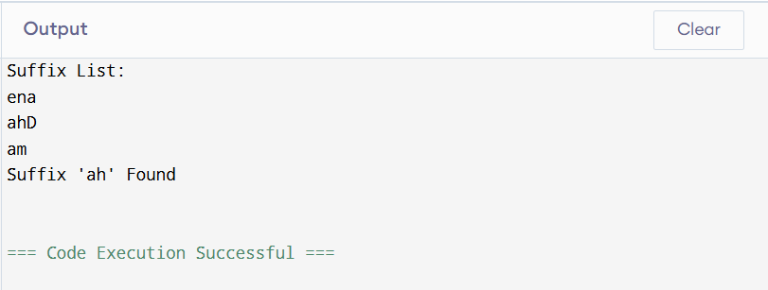

PROGRAM NO-24
#include <stdio.h>

struct Student {
int id;
char name[50];
float marks;
};

int main() {
struct Student s[3];
int i;

// Input data
for (i = 0; i < 3; i++) {
printf("Enter ID, Name, Marks:\n");
scanf("%d %s %f", &s[i].id, s[i].name, &s[i].marks);
}

// Display data
printf("\nStudent Records:\n");
for (i = 0; i < 3; i++) {
printf("ID: %d Name: %s Marks: %.2f\n",
s[i].id, s[i].name, s[i].marks);
}

return 0;
}
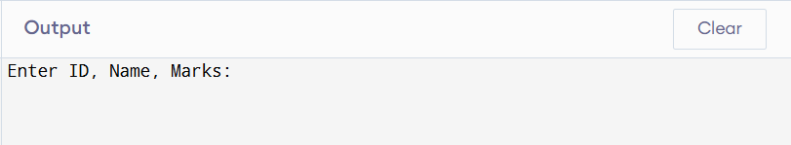

PROGRAM NO-25
#include <stdio.h>

// Function to calculate simple interest
float calculateInterest(float amount, float rate, int time) {
return (amount * rate * time) / 100;
}

int main() {
float loanAmount, rate, interest;
int time;

printf("Enter Loan Amount: ");
scanf("%f", &loanAmount);

printf("Enter Interest Rate: ");
scanf("%f", &rate);

printf("Enter Time (years): ");
scanf("%d", &time);

// Eligibility check
if (loanAmount <= 0) {
printf("Invalid Loan Amount\n");
return 0;
}

interest = calculateInterest(loanAmount, rate, time);

printf("\nLoan Details:\n");
printf("Loan Amount: %.2f\n", loanAmount);
printf("Interest: %.2f\n", interest);
printf("Total Repayment: %.2f\n", loanAmount + interest);

return 0;
}
